Mid-Programme Review of the Second Northern Ireland Climate Change Adaptation Programme (NICCAP2)

Northern Ireland’s second Climate Change Adaptation Programme (NICCAP2) was published in September 2019 and it covers the period 2019-2024. The programme contains NI Government’s response to the risks and opportunities relevant to Northern Ireland as identified in the UK Climate Change Risk Assessment 2017, setting out the policies and strategies to deliver against the priority areas.
NICCAP2 also contains a chapter which sits outside government, titled ‘Civil Society and Local Government Adapts’. The chapter is written by Climate NI, in conjunction with outside government stakeholders and was the first of its kind in the UK. Recognising that central government cannot act alone, this chapter was the first attempt to report on how Civil Society and Local Government sectors contribute to the national priority areas for action on climate risk and adaptation.
There is also a supporting document for this chapter with additional information on each of the projects and a NICCAP2 online platform on the Climate NI website showcasing each of the featured projects.
Submit New Projects
As part of the mid-programme review Climate NI is gathering new projects from civil society, academia, the private sector and local government to include in the mid-programme report. It is important to keep reporting on climate adaptation as up-to-date as possible, and it enables your organisation to showcase its work.
The purpose of this form is to capture details of new projects, policies or strategies which have been initiated (or are due to be initiated) during the lifespan of NICCAP2 (i.e. to September 2024) which help to deliver towards climate change adaptation action.
We welcome multiple submissions. Please send another form if you have more than one project to submit.

- Contact details

Responsible Organisation
Collaborating Organisations
Funder

- Key Priority Area Delivery

Please select, with an x, the relevant Key Priority Area and outcome from the options below (note more than one can be selected where actions / policies cut across):

NICCAP2 Key Priority Areas | NICCAP2 Outcome Objectives and Visions | Select
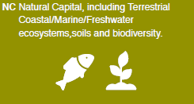 | 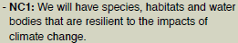
 | 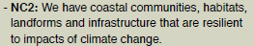
 | 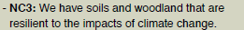
 | 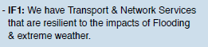
 | 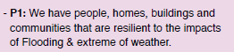
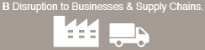 | 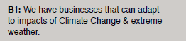
 | 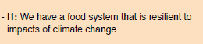

- Details of delivery action:

Please provide details of the project; to include title, commencement date and expected end date:

- Overview of delivery action:

Please provide a summary of how this project is delivering towards climate change adaptation and reducing the potential impacts of climate risks:

- Monitoring / indicators:
How are you monitoring or intend to monitor delivery progress? What are the associated indicators?

Thank you for taking time to complete this report, please return to Amy Bell by Thursday 30th June 2022 amy@climatenorthernireland.org.uk.

